COMP 3617

Assignment 2

Due Date:

3/11/2016 (@ 11:59PM)

Assignment Details

* The assignment involves creation of a very simple **MyTasks App**
* The purpose of this assignment is for you to explore and understand the workings of ListView, CustomListAdapter, ActionBar and implicit intents
* Assignments must be done individually and there should be no sharing of work amongst students. If you are found in violation of this, you will receive a “0” for the assignment and will be reported to BCIT
* The application allows the user to add, edit, display tasks at minimum
* For this assignment the tasks will be stored in the memory of the Android process running the application since we have not yet covered the data storage capabilities. To facilitate this functionality create a singleton TaskList class
* If there are any technical details missing, try to make realistic assumptions and build on them
* When you create the Android Application in Android Studio follow the exact instructions shown below (as you did in your assignment 1) with regard to naming the Application and Package. This is required to enable me to identify whose submission it is and also keep the number of assignment apps installed on my emulator to a small number.

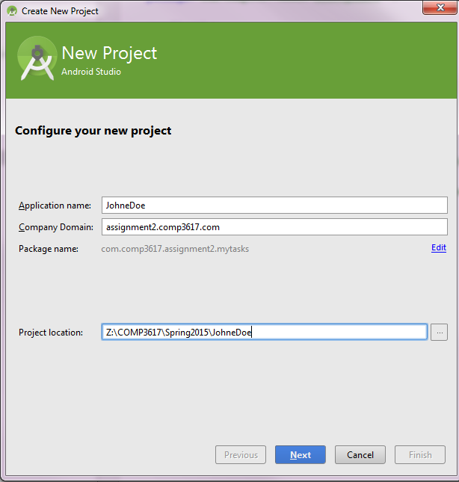

# To Hand In:

* Assignments must be zipped (.zip extension) up and uploaded to the drop box folder for the Assignment 2. Do not use any other compression utility other than plain windows zip
* Provide any special instructions, if you happen to have for your app, when you upload your assignment
* Assignment Zip files should be named as follows: **FirstNameLastName.zip** (Just zip up the Android Studio project for your app and this should follow the naming convention if you have followed the instructions)
* When you upload the zip file to drop box, add a comment stating how many hours you spent working on this assignment

# Requirements:

* Make use of Android Resource files everywhere possible and **avoid using literal strings/dimensions** in the application
* Make sure you set the minimum SDK to be at least 15
* You are encouraged to go beyond what has been asked for in terms of functionality, design in the app, but at minimum you should satisfy the basic features mentioned

## Data Model Classes (10 Points)

Create the following model classes

|  |  |
| --- | --- |
| Class/Interface | Description |
| Task | Task class captures information specific to a task  At minimum capture the following details about the task   * Title * Description * Status (Pending, Completed) * Due Date * Category (Populated from a resource file – for eg: work, home, personal etc) * Priority (Low, Med, High) |
| TaskList | A singleton class that has an array list of Tasks it encapsulates and provides a way to retrieve, edit and add tasks. |

## Activities (30 Points)

Create the following Activities at minimum:

|  |  |
| --- | --- |
| Activity | Description |
| DisplayTasksActivity | Displays tasks. Make use of ListView. This will be main activity for the app. Display an add icon in the action bar to navigate to the AddTaskActivity.  Clicking on a task in the list view navigates to the EditTaskActivity. The Edit Task activity brings up the task selected and populates the details of the task and allows it to be edited.  Display the task details using a custom layout for each row. In the custom layout make use of icons that can display the different priorities/status and text to display the title and brief description |
| AddTaskActivity | Captures the task details from the activity and add it to the task list. Provide the capability to set a reminder in the calendar by clicking a checkbox for 8am on the day the task is due. (The Calendar functionality will not work in the emulator, but I would like to explore how you go about implementing this in code) |
| EditTaskActivity | Allows the user to edit the task detail or delete the task. Allows the task details to be emailed or shared (The email functionality will not work in the emulator, but once again I want to explore how you go about implementing this in code) |

## Design (10 Points)

Design and Coding conventions

Hint: For the Calendar and Email functionality, you should be leveraging Intents and not Calendar API